The first type is variables, and the second one is constants.

normally you come in, and you put an asterisk at the start of each line, there's a quick way of doing this, if you highlight the lines of code that you want to comment, then you can hold down the control key and the less than sign and it will automatically select the asterisk in the first column of the ABAP Editor.

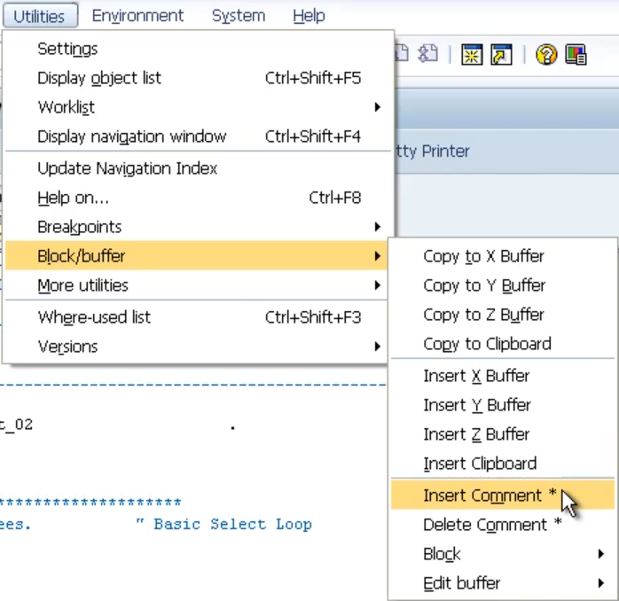

Comment a line, if you can't remember your key presses, another way to do this. Is through the utilities menu. Under the block/buffer, choose insert comment.

There are many other uses for fields within the program whilst creating your own programs and reading other programs created by other people.

there are a few rules for variables that you got to follow. They must start with a letter; they can have a maximum size of thirty characters. You cannot include the plus, comma, colon, and parentheses in the name. And you cannot use a reserved word.

Now we declare variables. By using the data statements.

**DATA INTEGER01 TYPE I.**

Packed Decimal

**DATA PACKED_DECIMAL01 TYPE P DECIMALS 2.**

packed decimal is there to help store numbers with decimal places. the packed decimal is that it can store up to fourteen decimal places.

**DATA PACKED_DECIMAL02 LIKE PACKED_DECIMAL02.**

So, as well as declaring variables this way, we have another option of declaring variables. Using what we call the like addition to the data statements. So, we can declare a brand-new variable we'll call it pipe decimal and instead of using the word type this time we're going to use the word **like** and we're going to say like the packed decimal field that we have already defined. Now what this effectively does is makes sure that the new variable called packed decimal. Takes on exactly the same properties That we defined for packed decimal.

**DATA NEW_SURNAME LIKE ZEMPLOYEE-SURNAME.**

We can refer to variables or fields in this case that exist in tables within the sub system.

We can declare a new variable within our program. And we can say, it's going to be like table name zemployees. dash, then the actual field name.

**DATA INTEGER01 TYPE I VALUE 22.**

**DATA PACKED_DECIMAL02 LIKE PACKED_DECIMAL02 VALUE ‘5.5’.**